vSphere Replication—Incoming Replications—select VM which you want to power on from DR site.

It should show the status OK and make a not Last instance sync point time. If it showing old better to rysync for latest.

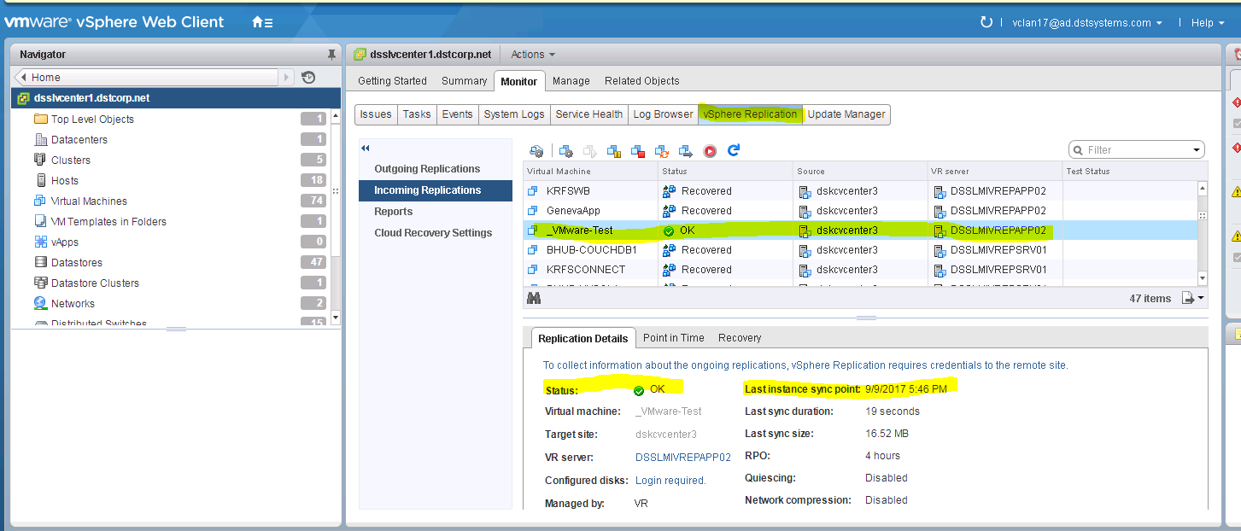

Right click VM

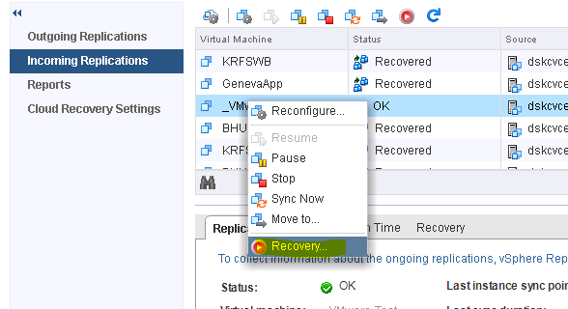

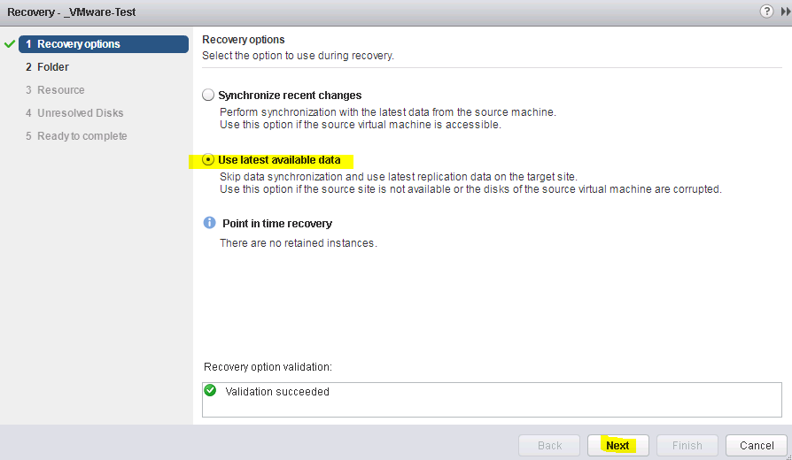

Select folder as per OS Linux or Windows

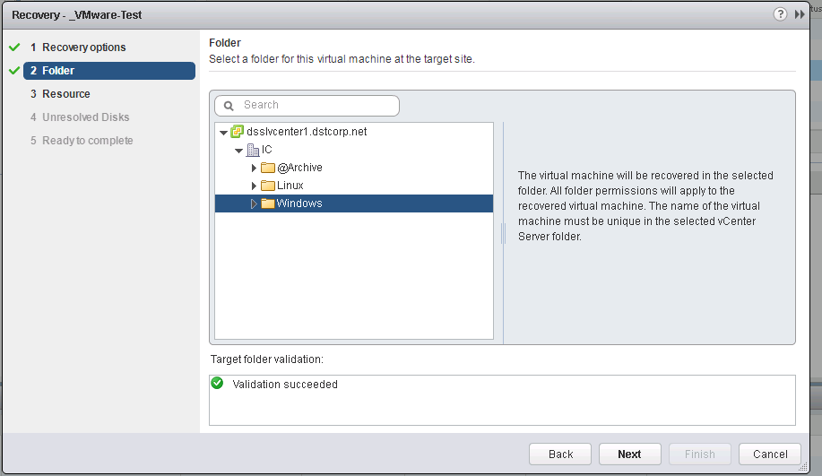

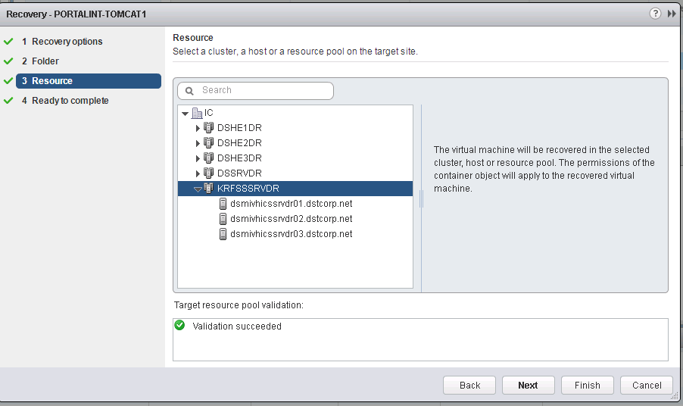

Finish it off and power on

